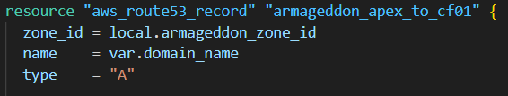
- zone_id: Which hosted zone in Route 53 you’re writing into (example: hosted zone for librashift.com)
- name = var.domain_name: This is your apex/root domain, like librashift.com
- type = "A": A-record (but with alias, it won’t store an IP)

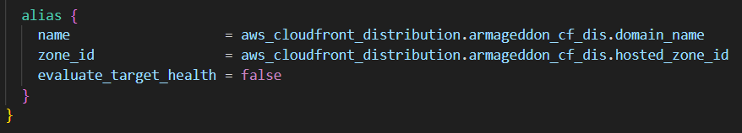
- alias.name: The CloudFront distribution DNS name, like d123abcd.cloudfront.net
- alias.zone_id: CloudFront’s hosted zone id (AWS provides this on the distribution object)
- evaluate_target_health = false: Route 53 won’t try to do Route53 health-check evaluation for this alias target.
✅ Result: yourdomain.com points at CloudFront.

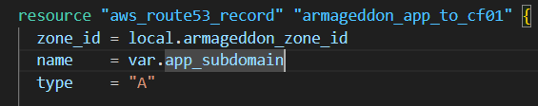
Same hosted zone.
name = var.app_subdomain: This is your app record name, usually something like:
- app (which Route 53 interprets as app.yourdomain.com in that zone), or
- app.yourdomain.com (fully-qualified). Either works if you’re consistent.

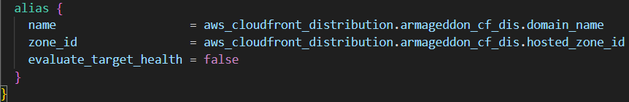
Result: app.yourdomain.com also points at the same CloudFront distribution.
Why do both apex and app go to the same CloudFront?
- You might serve the same site on both
- Or CloudFront behaviors/routes handle differences

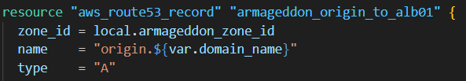
Creates origin.yourdomain.com explicitly
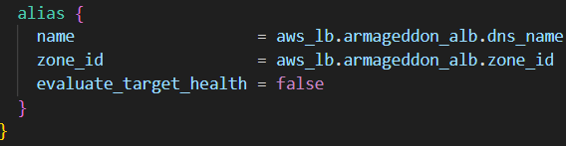
- Points that origin.yourdomain.com name to your Application Load Balancer.
- aws_lb.armageddon_alb.dns_name looks like my-alb-123456.us-east-1.elb.amazonaws.com
- aws_lb.armageddon_alb.zone_id is the ALB’s hosted zone id for aliasing.
Result: origin.yourdomain.com goes directly to the ALB.

Why have an origin. record at all?
- Often you set CloudFront’s origin to origin.yourdomain.com (cleaner than using the raw ELB DNS name)
- You can rotate/replace the ALB later without changing CloudFront config as much (just update DNS)
- You can lock down the ALB so only CloudFront can reach it (your “origin cloaking” setup)

